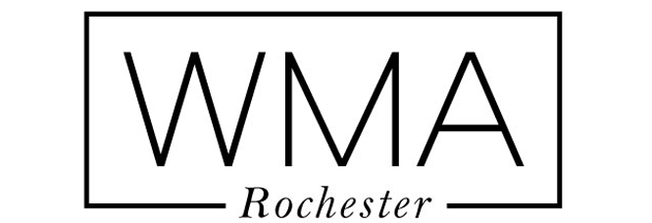 STEVE ABBOTT
585-244-0592
____________________________________________________________________________________________________
FILM(Feature)

MARSHALL OPEN ROAD FILMS REGINALD HUDLIN

DEATH OF A PRESIDENT BOUROUGHS (BBC) GABRIEL RANGE

GACY RELLINGTON CLIVE SAUNDERS
HARDBALL PARAMOUNT BRIAN ROBBINS
UNCONDITIONAL LOVE PARAMOUNT P.J.HOGAN
UNDER SIEGE 2: Dark Territory WARNER BROS. GEOFF MURPHY
THINGS TO DO IN DENVER… MIRAMAX GARY FLEDER

FILM(Shorts)
THE SECOND HALF ABOUT TIME PRODS. STEVE ABBOTT
SUPERFUME (Awarded) SHOEBOX CINEMA KEVIN DONNER
MY TURN (Winner/Awarded) KEEN EYE PRODS. SHELLY DUVALL
THE PICNIC SHOEBOX CINEMA KEVIN DONNER
THE RADIO BGR PRODUCTIONS MATT WEINER
THE CLOSER SHOEBOX CINEMA KEVIN DONNER
BACK TO ME (Awarded) ABOUT TIME PRODS. STEVE ABBOTT
JESUS CHRONICLES (Series) DOUBLE TAKE TODD VALCOURT
NO, YOU AIN’T ALRIGHT SAWGRASS PRODS. MICHAEL RINGSTON
BIRTHDAY (Awarded) WE GO BRAINS NEAL TEN EYCK
FIVE ZERO (Series) ABOUT TIME PRODS. STEVE ABBOTT
FIND HER CCC PRODUCTIONS TIM DONOVAN
EVERYBODY SINS INDEPENDENT BRAIN McQUERY
OH WELL(Winner/Awarded) INDEPENDENT TIM MALOOLY

TELEVISION
BORED TO DEATH HBO MICHAEL LEHMANN
CROSSING JORDAN NBC ALAN ARKUSH
ALIAS ABC ALEX KURTZ
BERNIE MAC FOX KEVIN BRAY
L.A. HEAT USA KEVIN MOCK
MURDER ONE ABC ADAM NIMOY
THE PRETENDER NBC JESUS S. TREVINO
HIGH INCIDENT ABC D.J. CARUSO
IF LOOKS COULD KILL (mow) FOX SHELDON LARRY
DIAGNOSIS MURDER CBS LOU ANTONIO

COMMERCAILS
List upon request

TRAINING-Chicago
The Second City Conservatory Program Norm Holly
The Actor’s Studio Master On-Camera Jane Alderman
The Audition Studio On Camera 1 and 2 Rachel Patterson

